# CS 255 System Design Document Template

## UML Diagrams

### UML Use Case Diagram

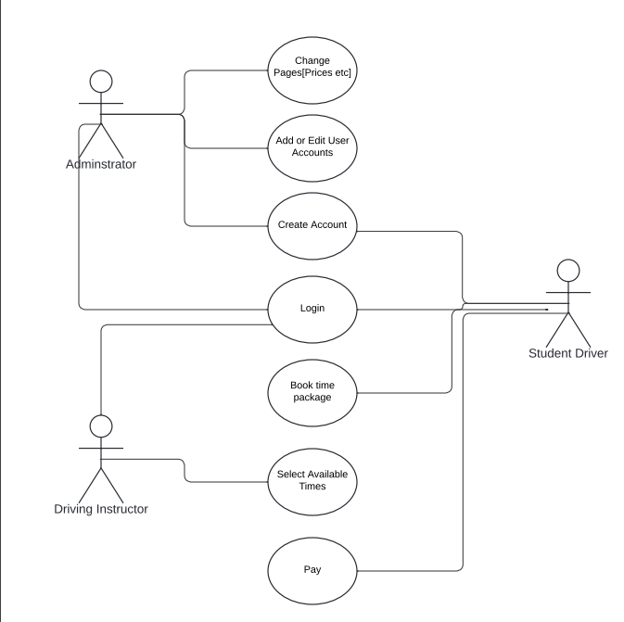

### UML Activity Diagrams

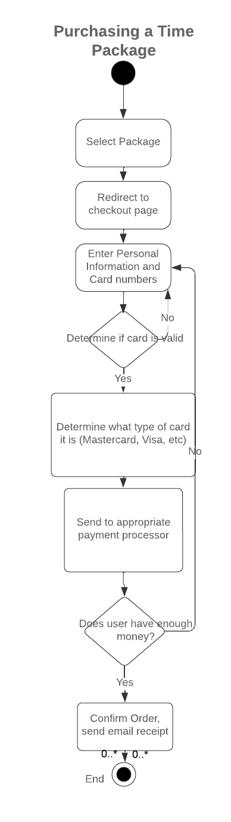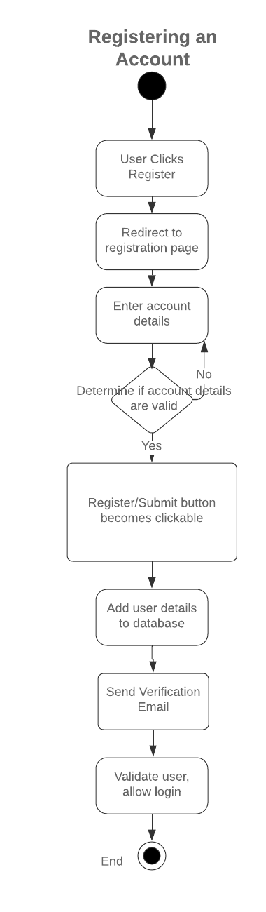

### UML Sequence Diagram

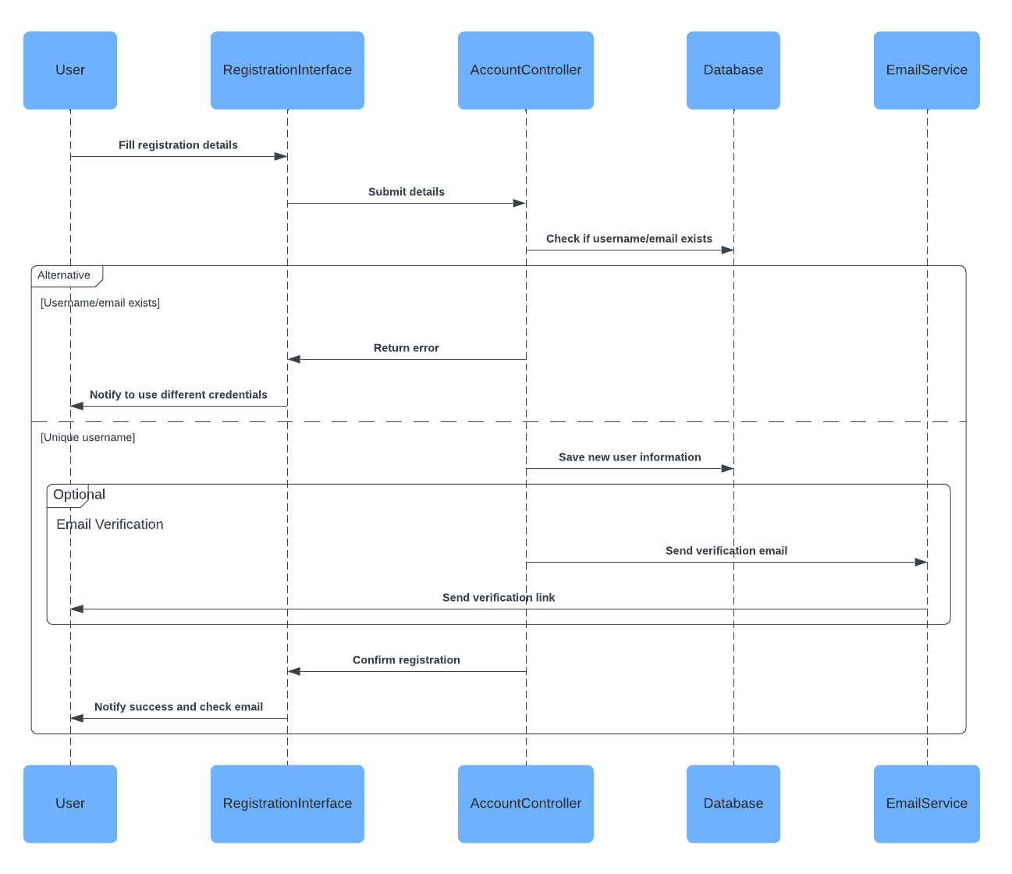

### UML Class Diagram

## 

## Technical Requirements

Based on the diagrams, the technical requirements will include many components. In regards to hardware, we will require a web server that can serve content to users and enough storage space to comfortably store several databases. There should also be a secondary backup of the website and important information. In regards to software, we will require an operating system such as Linux, webserver software like Apache, and a database manger like MySQL. Tools like cPanel can also be used so as to allow the client to easily make alterations after delivery. Required infrastructure would include access to electricity and the internet.